Project Report
1. INTRODUCTION
1.1 Project Overview
1.2 Purpose
2. IDEATION PHASE
2.1 Problem Statement
2.2 Empathy Map Canvas
2.3 Brainstorming
3. REQUIREMENT ANALYSIS
3.1 Customer Journey map
3.2 Solution Requirement
3.3 Data Flow Diagram
3.4 Technology Stack
4. PROJECT DESIGN
4.1 Problem Solution Fit
4.2 Proposed Solution
4.3 Solution Architecture
5. PROJECT PLANNING & SCHEDULING
5.1 Project Planning
6. FUNCTIONAL AND PERFORMANCE TESTING
6.1 Performance Testing
7. RESULTS
7.1 Output Screenshots
8. ADVANTAGES & DISADVANTAGES
9. CONCLUSION
10. FUTURE SCOPE
11. APPENDIX
GitHub & Project Demo Link

1.INTRODUCTION
1.1 Project Overview:
OrderOnTheGo – On-Demand Food Ordering Platform is a full-stack web application designed to simplify and digitize the process of ordering food from restaurants through a centralized online system. Traditional food ordering methods often involve limited menu visibility, manual coordination, longer waiting times, and inefficient communication between customers and restaurants. This project aims to address these challenges by providing a modern digital platform where users can browse restaurant menus, select food items, and place orders conveniently.
Customers can explore available restaurants, add items to their cart, and track order status in real time. Restaurant owners can manage menus, monitor incoming orders, and update order status efficiently through a dedicated dashboard. Administrators oversee platform operations, approve restaurant registrations, and ensure secure system management.
The application follows a modern client-server architecture using React.js for the frontend interface, Node.js and Express.js for backend services, and MongoDB Atlas for data storage and management.
1.2 Purpose:
The primary purpose of the OrderOnTheGo application is to enhance convenience, efficiency, and accessibility in online food ordering through a centralized digital solution. The project focuses on reducing manual ordering processes, improving communication between customers and restaurants, and delivering a seamless user experience.
Key objectives of the system include:
- Provide an intuitive platform for customers to discover restaurants, browse menus, and place food orders online.
- Allow restaurant owners to efficiently manage menu items, track orders, and update delivery status.
- Enable administrators to maintain platform governance and ensure secure operations.
- Deliver order status updates, notifications, and smooth user interactions.
- Build a scalable and user-friendly food ordering system using modern MERN stack technologies.
Overall, the project aims to bridge the gap between customers and restaurants by offering a reliable and structured food ordering solution that enhances user satisfaction and operational efficiency
2.IDEATION PHASE
2.1 Problem Statement:
In today’s fast-paced lifestyle, ordering food from restaurants can often be time-consuming and inconvenient for both customers and restaurant owners. Traditional ordering methods may lack centralized menu visibility, real-time order tracking, and efficient communication between customers and restaurants. This can lead to delayed orders, incorrect requests, and reduced customer satisfaction. The OrderOnTheGo platform aims to address these challenges by providing a centralized digital food ordering solution
Problem Statement :
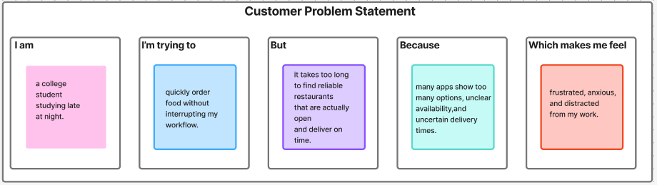

Problem Statement (PS) | I am | I’m trying to | But | Because | Which makes me feel
PS-1 | a hungry user ordering food during unconventional hours. | make a confident decision about what to eat. | I cannot fully trust the reviews, pricing clarity, and final delivery cost shown upfront. | hidden charges and inconsistent experiences have reduced my trust in food delivery platforms. | uncertain and hesitant before placing my order.
PS-2 | a time-sensitive user with low energy late at night. | complete my order in the fastest and simplest way possible. | the checkout process feels lengthy and requires multiple steps and repeated information. | the platform does not minimize effort or support quick decision-making. | mentally drained and impatient.
2.2 Empathy Map:
User: - Leisha(Studies At Late Night)
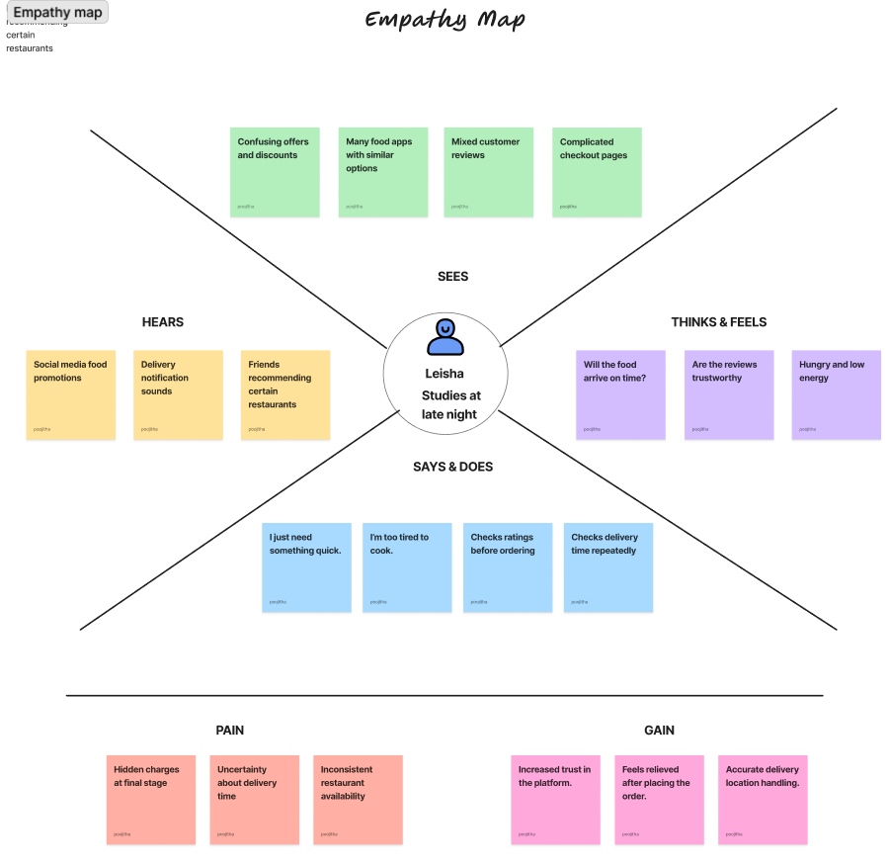
2.2 Brainstorm & Idea Prioritization:-
Step-1: Team Gathering, Collaboration and Select the Problem Statement
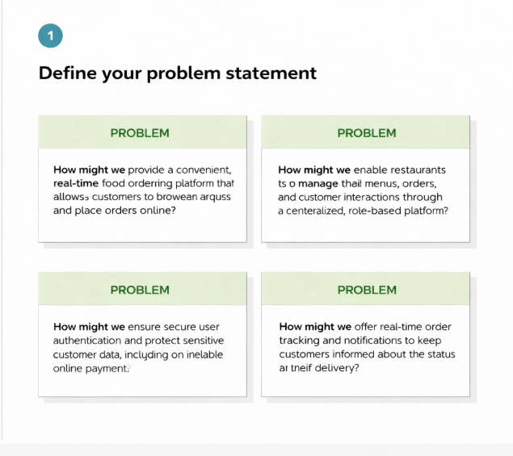
Step-2: Brainstorm, Idea Listing and Grouping
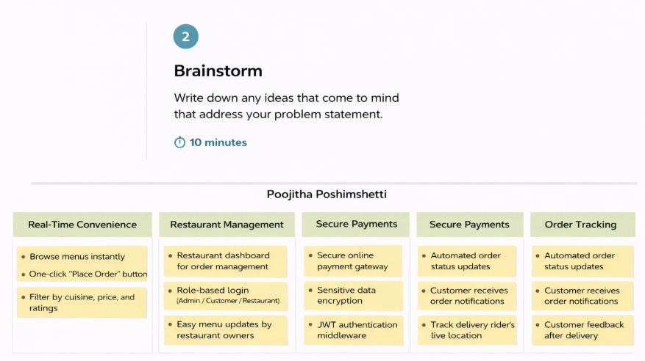
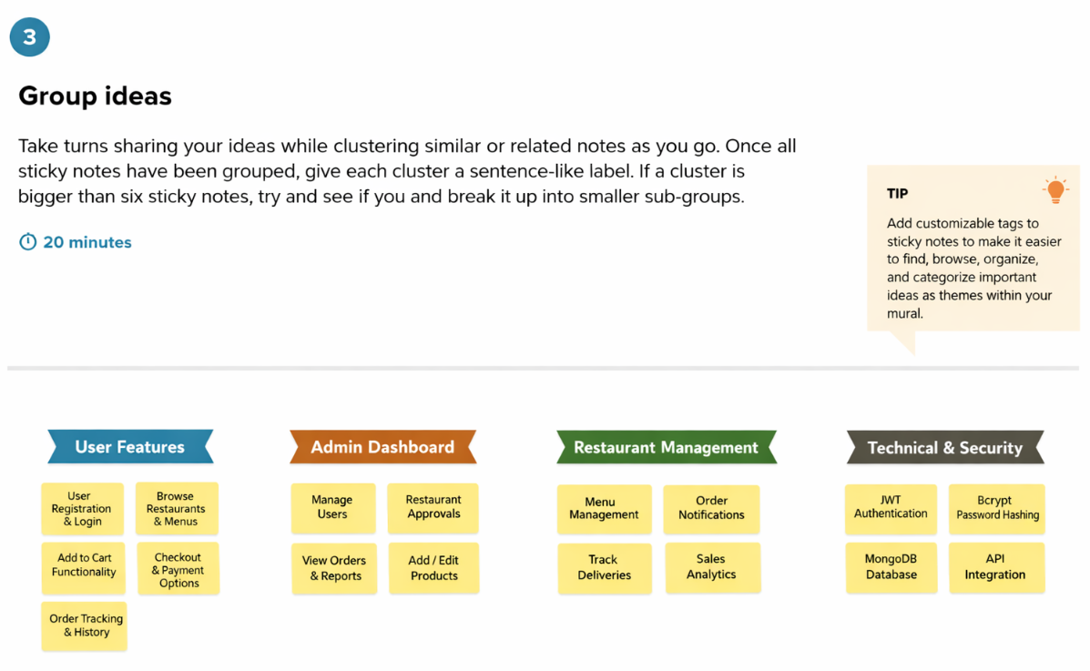

Step-3: Idea Prioritization
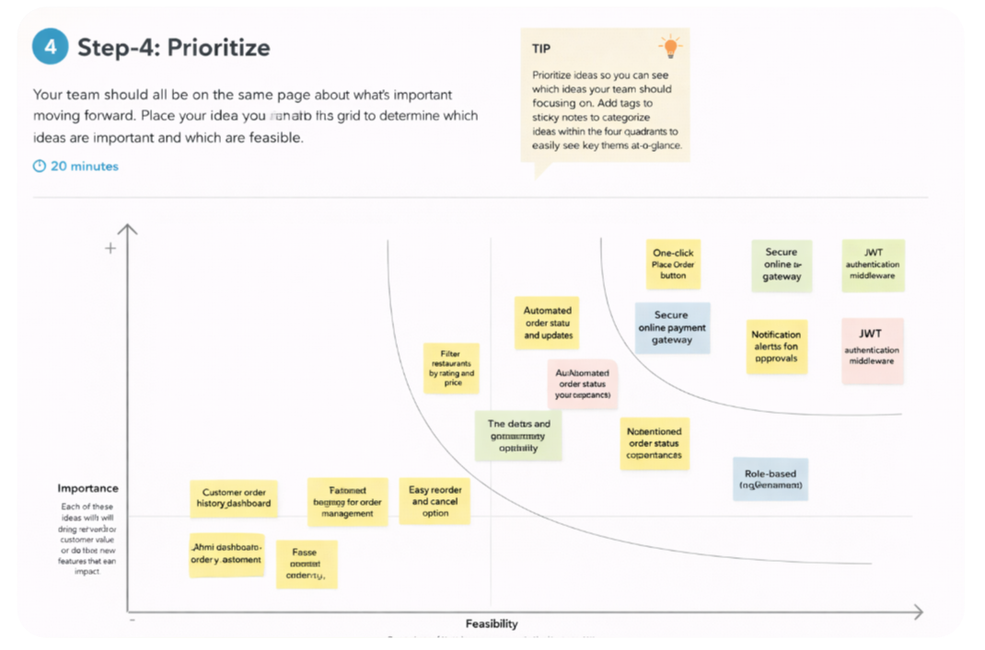
REQUIREMENT ANALYSIS
3.1 Customer Journey map:
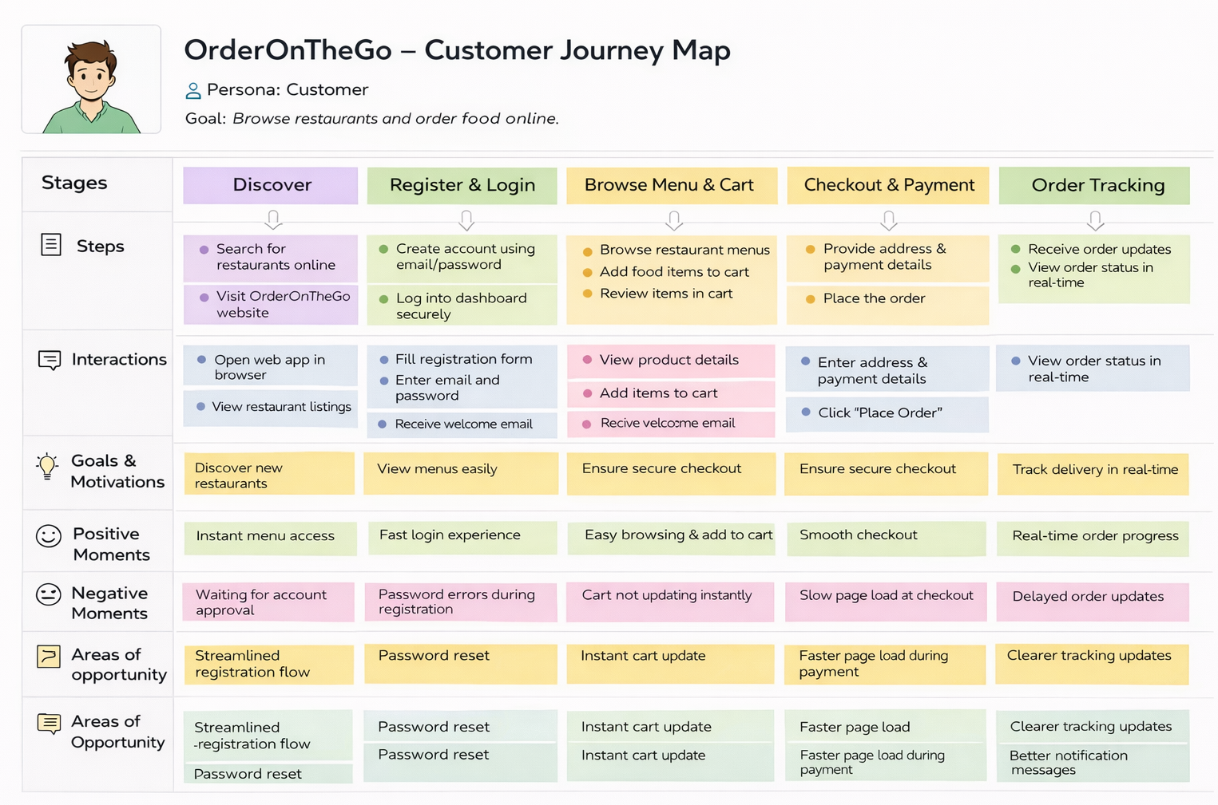
3.2 Solution Requirement
Functional Requirements:
Following are the functional requirements of the proposed solution.
FR No. | Functional Requirement (Epic) | Sub Requirement (Story / Sub-Task)
FR-1 | User Registration | Users can register by providing name, email, password and  Contact details.  Store encrypted password in database.
FR-2 | User Confirmation | Users can log in using registered credentials.  System verifies credentials using JWT authentication  Users can logout securely.
FR-3 | Product Browsing & Filtering | Users can place orders from cart.  Users enter delivery address and payment details.  Order confirmation message is generated.
FR-4 | Cart Management | Users can add products to cart.  Users can update quantity or remove items from cart
FR-5 | Order Placement | Users can place orders from cart.  Users enter delivery address and payment details.  Order confirmation message is generated.
FR-6 | Order Tracking & History | Users can view past orders in profile section.  System stores order date, items, and payment status.
FR-7 | Admin Management | Admin can login securely.  Admin can manage users, products, restaurants, and orders.
FR-8 | Restaurant Dashboard | Restaurants can add/edit/delete menu items.  Restaurants can view received orders.

Non-functional Requirements:
Following are the non-functional requirements of the proposed solution.
FR No. | Non-Functional Requirement | Description
NFR-1 | Usability | The system provides a user-friendly interface with easy navigation, responsive design, and simple checkout process.
NFR-2 | Security | User passwords are encrypted using hashing techniques. JWT authentication is implemented. Admin routes are protected.
NFR-3 | Reliability | The system ensures accurate order processing and secure database transactions without data loss.
NFR-4 | Performance | The application provides fast page loading, optimized API responses, and efficient database queries.
NFR-5 | Availability | The system is available 24/7 and supports late-night food ordering.
NFR-6 | Scalability | The system architecture supports adding more restaurants, users, and products without affecting performance.

3.3 Data Flow Diagram: -
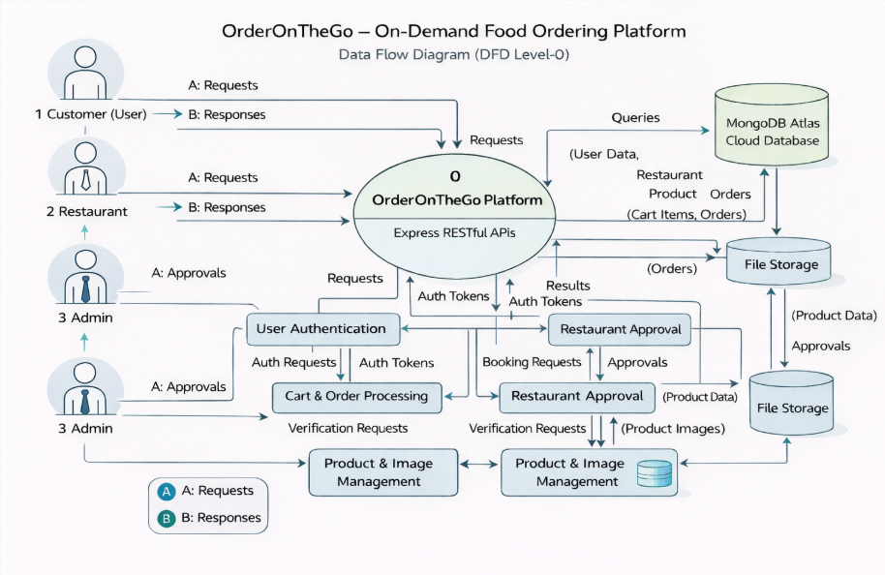
User Stories
User Type | Functional Requirement (Epic) | User Story Number | User Story / Task | Acceptance criteria | Priority | Release
Customer (Web User) | Registration | USN-1 | As a customer, I can register  using email and password | Account created & dashboard accessible | High | Sprint-1
Customer (Web User) | Authentication | USN-2 | As a customer, I can log in  securely | Successful login redirects to home page | High | Sprint-1
Customer (Web User) | Restaurant Listing | USN-3 | As a customer, I can view  available restaurants and  food items | Restaurant list  loads from  database | High | Sprint-1
Customer (Web User) | Add to Cart | USN-4 | As a customer, I can add food items to cart | Items appear in cart with quantity | High | Sprint-2
Customer (Web User) | Order Placement | USN-5 | As a customer, I can place orders with address and payment method | Order status shows “Placed” | High | Sprint-2
Restaurant | Product  Manage  ment | USN-6 | As a restaurant, I can add/edit  /delete food items | Products updated in dashboard | High | Sprint-3
Administrator | Restaurant Approval | USN-7 | As an admin, I can approve  restaurant registrations | Approved restaurant visible to users | High | Sprint-3
Customer (Web User) | Notifications | USN-8 | As a customer, I receive order updates | Order confirmation displayed on dashboard | Medium | Sprint-4
Customer (Web User) | Order History | USN-9 | As a customer, I can view  previous orders | Order history visible in profile | Medium | Sprint-5

3.4 Technology Stack: -
Technical Architecture: -
The OrderOnTheGo application follows a 3-Tier Client–Server Architecture designed to ensure scalability, maintainability, and secure communication between system components.
- Presentation Layer (Frontend): This layer handles menu browsing, cart management, order placement, dashboard views, and user profile management.
- Application Layer (Backend): The backend is built using Node.js and Express.js, which manage API requests, user authentication, order processing, restaurant management, and role-based access control. RESTful APIs enable communication between frontend and backend services.
- Data Layer (Database): The data layer uses MongoDB Atlas, a cloud-based NoSQL database.
The frontend communicates with backend REST APIs using Axios for efficient HTTP requests.
Protected routes are secured using JWT authentication, ensuring that only authorized users can access role-specific dashboards and actions.
Table-1: Components & Technologies:
S. No | Component | Description | Technology
 | User Interface | Web interface for users, restaurants, and admin dashboards | React.js, HTML, CSS, Bootstrap.
 | Application Logic-1 | Authentication & Role Management | Node.js, Express.js, JWT
 | Application Logic-2 | Food ordering, cart management, checkout process | Express.js REST APIs
 | Application Logic-3 | Order status tracking & notifications | Node.js Controllers
 | Database | Stores users, restaurants, products, cart, and orders | MongoDB, Mongoose
 | Cloud Database | Cloud-based NoSQL storage for scalable data access | MongoDB Atlas
 | File Storage | Stores food images and restaurant media files | Local File System / Cloud Storage
 | External API-1 | Frontend to backend communication | Axios
 | External API-2 | Not Applicable | __

Table-2: Application Characteristics:
S. No | Characteristics | Description | Technology
 | Open-Source Frameworks | Frameworks used to build UI & Backend APIs | React.js, Express.js, Node.js
 | Security Implementations | Role-based authentication, encrypted passwords, protected routes | JWT, bcryptjs, Middleware
 | Scalable Architecture | Separation of frontend, backend, and database layers | REST Architecture, MongoDB
 | Availability | Web application accessible anytime through browser | Node.js Server
 | Performance | Fast API responses and asynchronous communication | Axios, Express.js

4. PROJECT DESIGN
4.1 Problem Solution Fit:
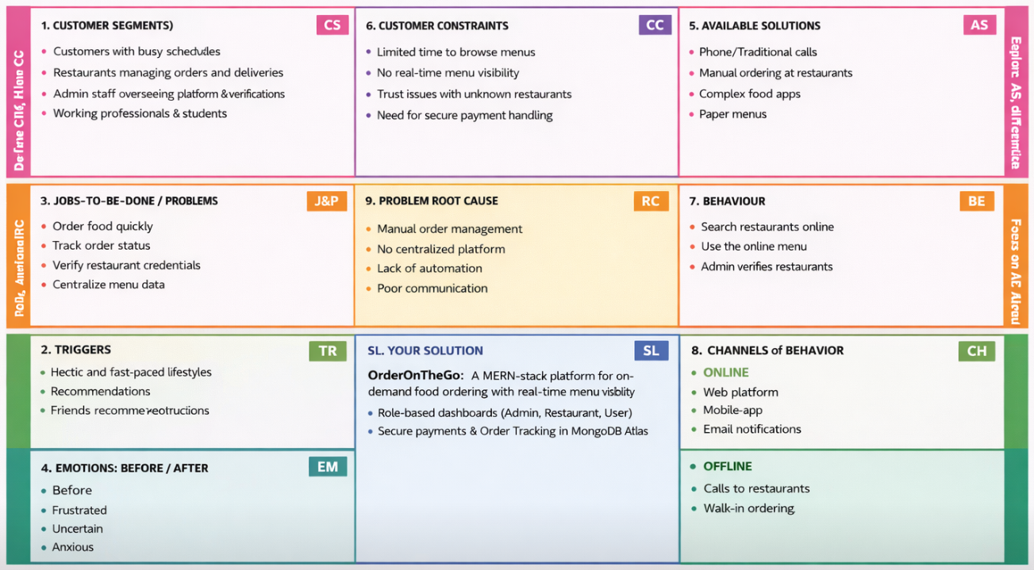
4.2 Proposed Solution:
S.No. | Parameter | Description
 | Problem Statement (Problem to be solved) | Customers often face difficulty ordering food quickly due to long waiting times, lack of centralized restaurant menus, and inefficient manual ordering methods. Restaurants struggle to manage orders and update menus efficiently, while admins need a secure system to monitor restaurant approvals, products, and user activities in one platform.
 | Idea / Solution description | OrderOnTheGo is a MERN-stack web application that enables users to browse restaurants, add food items to cart, and place orders through a centralized online system. It provides role-based dashboards for Admin, Restaurant, and Customer with secure JWT authentication, product management, real-time order processing, and REST APIs connected to MongoDB Atlas.
 | Novelty / Uniqueness | Role-based food ordering workflow, admin-controlled restaurant approvals, centralized product catalog, dynamic cart system, secure authentication, and a responsive user-friendly ordering interface that simplifies the food ordering experience.
 | Social Impact / Customer Satisfaction | Reduces waiting time for customers, improves restaurant order management, provides clear menu visibility, and enhances user convenience through a fast and secure digital food ordering experience.
 | Business Model (Revenue Model) | Commission-based model from restaurant orders, premium restaurant listings, promotional banners, and potential future integration of delivery tracking and subscription-based restaurant promotions.
 | Scalability of the Solution | Built using a 3-tier MERN architecture (React frontend, Node.js/Express backend, MongoDB Atlas database), enabling scalable performance, easy deployment, and seamless expansion to support more users, restaurants, and features.

4.3 Solution Architecture:
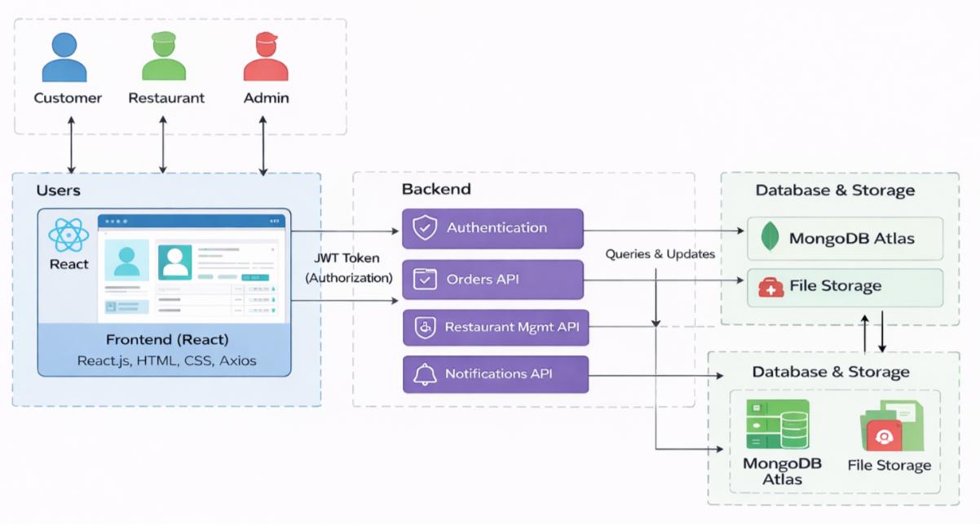
Figure-1: Architecture and data flow of the OrderOnTheGo MERN-stack food ordering platform.

5. PROJECT PLANNING & SCHEDULING
5.1 Project Planning:
Product Backlog, Sprint Schedule, and Estimation :
Sprint | Functional Requirement (Epic) | User Story Number | User Story / Task | Story Points | Priority | Team Members
Sprint-1 | Registration | USN-1 | As a customer, I can register using email and password to access the platform. | 2 | High | Team
Sprint-1 | Authentication | USN-2 | As a user, I can log in securely using JWT authentication. | 2 | High | Team
Sprint-1 | Dashboard | USN-3 | As a customer, I can view restaurant listings and food items on the dashboard. | 3 | High | Team
Sprint-2 | Product Browsing | USN-4 | As a customer, I can browse menus and view product details such as price and description. | 5 | High | Team
Sprint-2 | Cart Management | USN-5 | As a customer, I can add or remove food items from the cart before ordering. | 3 | Medium | Team
Sprint-3 | Order Processing | USN-6 | As a customer, I can place an order by providing address and payment details. | 5 | High | Team
Sprint-3 | Restaurant Panel | USN-7 | As a restaurant owner, I can add, update, and manage food products. | 4 | High | Team
Sprint-4 | Admin Panel | USN-8 | As an admin, I can approve restaurants and manage platform data. | 3 | Medium | Team
Sprint-4 | Order History | USN-9 | As a customer, I can view my order history and order status updates. | 3 | Medium | Team

Project Tracker, Velocity & Burndown Chart:
Sprint | Total Story Points | Duration | Sprint Start Date | Sprint End Date (Planned) | Story Points Completed (as on Planned End Date) | Sprint Release Date (Actual)
Sprint-1 | 15 | 4 Days | 01 Feb 2025 | 04 Feb 2025 | 15 | 04 Feb 2025
Sprint-2 | 16 | 4 Days | 05 Feb 2025 | 08 Feb 2025 | 16 | 08 Feb 2025
Sprint-3 | 14 | 4 Days | 09 Feb 2025 | 12 Feb 2025 | 14 | 12 Feb 2025
Sprint-4 | 12 | 3 Days | 13 Feb 2025 | 15 Feb 2025 | 12 | 15 Feb 2025

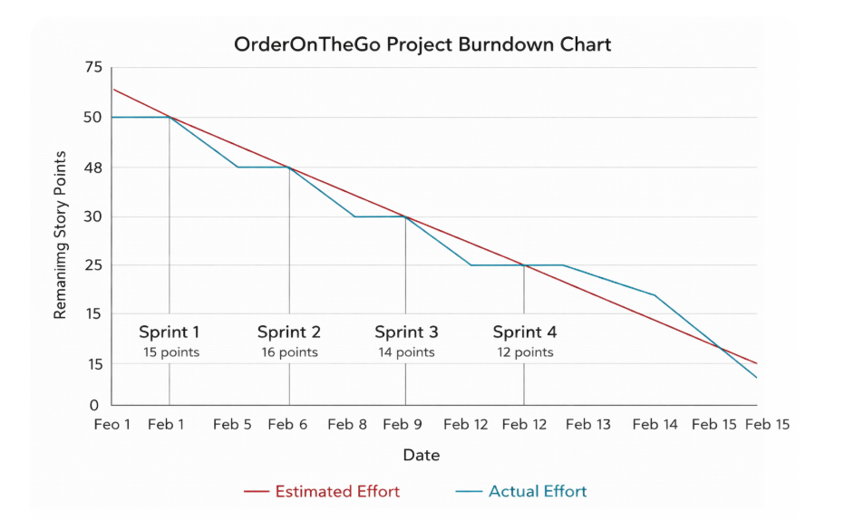
6. FUNCTIONAL AND PERFORMANCE TESTING
6.1 Performance Testing:
Project Overview:
Project Name: DocSpot: OrderOnTheGo: On-Demand Food Ordering Platform
Project Description: OrderOnTheGo is a MERN-stack web application that enables customers to browse restaurants, add food items to cart, and place orders online with real-time menu visibility. The platform provides role-based dashboards for Admin, Restaurant, and Customer, secure JWT authentication, product management, and order status tracking using MongoDB Atlas.
Project Version: v1.0
Testing Period: 12 Feb 2025 to 15 Feb 2025
Testing Scope:
Features Tested:
- User Registration & Login
- Role-based Dashboard(Customer, Restaurant, Admin)
- Restaurant Listing & Product Menu
- Cart Management & Order Placement
- Restaurant Approval Workflow
- Order Status Updates & Notifications
User Stories Tested:
- USN-1 Registration
- USN-2 Login
- USN-4 Product Browsing & Cart
- USN-6 Order Placement
- USN-8 Notifications
Testing Environment:
URL/Location: http://localhost:3000
Credentials (if required): User → testuser@gmail.com / ******
Restaurant → restest@gmail.com / ******
Admin → admin@gmail.com / *****
Test Cases:

Test Case ID | Test Scenario | Test Steps | Expected Result | Actual Result | Pass/Fail
TC-001 | User Registration | Step1: Open Register Page  Step2: Enter user details  Step3: Submit | User account created successfully | Account created | Pass
TC-002 | User Login | Step1: Enter email & password  Step2: Click Login | Redirect to dashboard | Dashboard loaded | Pass
TC-003 | View  Restaurants | Step1: Login  Step2: Open Home Dashboard | Restaurant list displayed | Restaurants visible | Pass
TC-004 | Add to Cart | Step1: Select food item  Step2: Click Add to Cart | Item added to cart | Cart updated | Pass
TC-005 | Place Order | Step1: Open Cart  Step2: Enter address & payment  Step3: Submit Order | Order created successfully | Order pending | Pass
TC-006 | Restaurant Product Management | Step1: Restaurant logs in  Step2: Add new product | Product added to menu | Product visible | Pass
TC-007 | Admin Approval | Step1: Admin logs in  Step2: Approve restaurant | Restaurant status updated | Approved successfully | Pass
TC-008 | Order Status Update | Step1: Restaurant updates order status | Status changes to Preparing/Delivered | Status updated | Pass

Bug Tracking:

Bug ID | Bug Description | Steps to reproduce | Severity | Status | Additional feedback
BG-001 | Minor UI alignment issue in restaurant dashboard | Step-1: Login as Restaurant  Step-2: Open Product Management page | Low | Closed | Fixed using CSS update
BG-002 | Cart count not updating instantly after adding item | Step-1: Login as Customer  Step-2: Add product to cart | Medium | Closed | Fixed using state refresh & API call optimization
BG-003 | Slow image loading for food items on low internet | Open Home page with multiple products | Medium | In Progress | Image compression & lazy loading suggested

Sign-off:
Tester Name: Poshimshetti Poojitha
Date: 15 February 2025
Signature: Poshimshetti Poojitha

7. RESULTS
7.1 Output Screenshots:
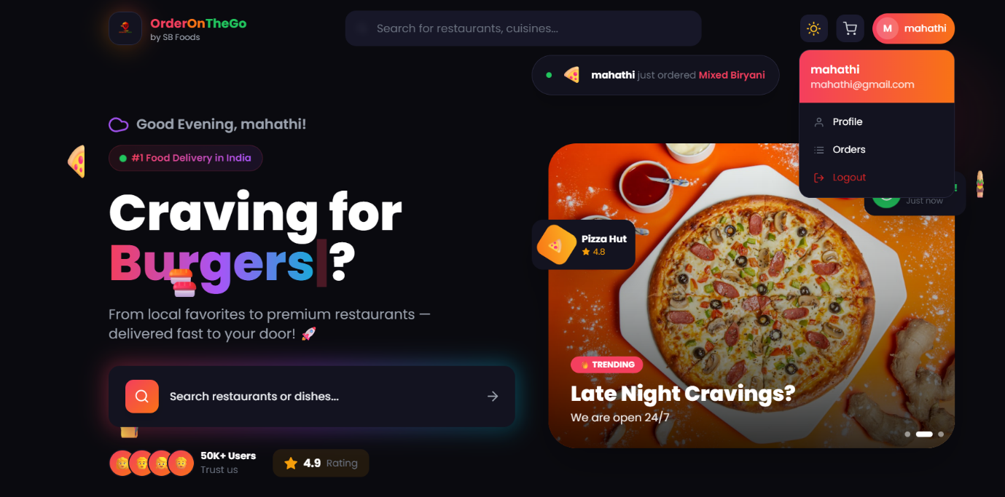
Figure-2: Customer Dashboard
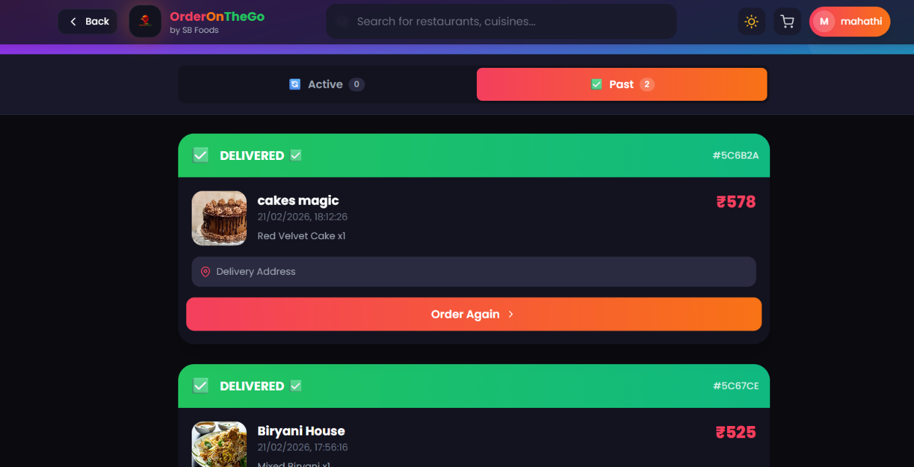
Figure-3: Order History

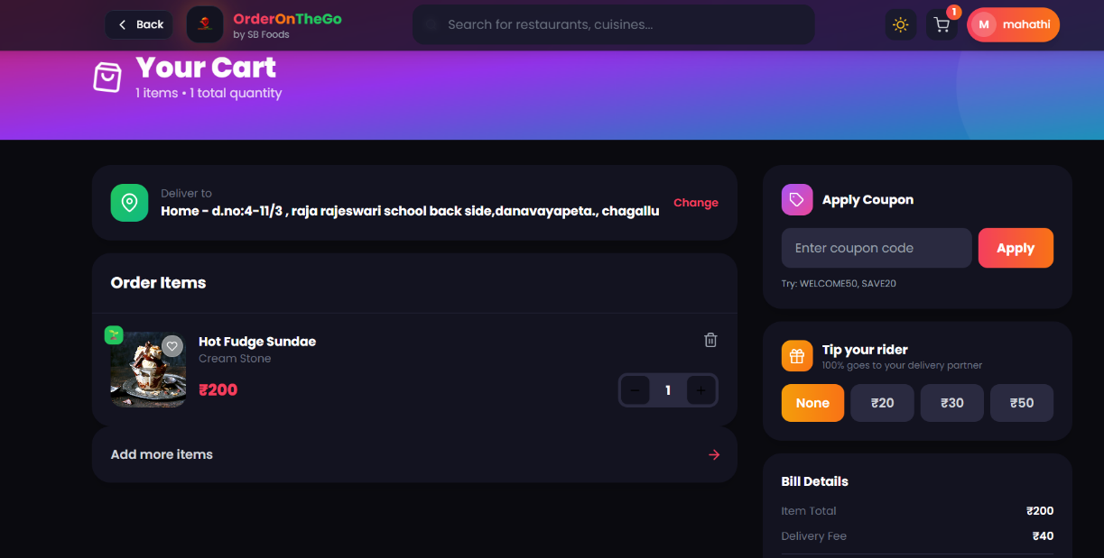
Figure-4: Cart Page

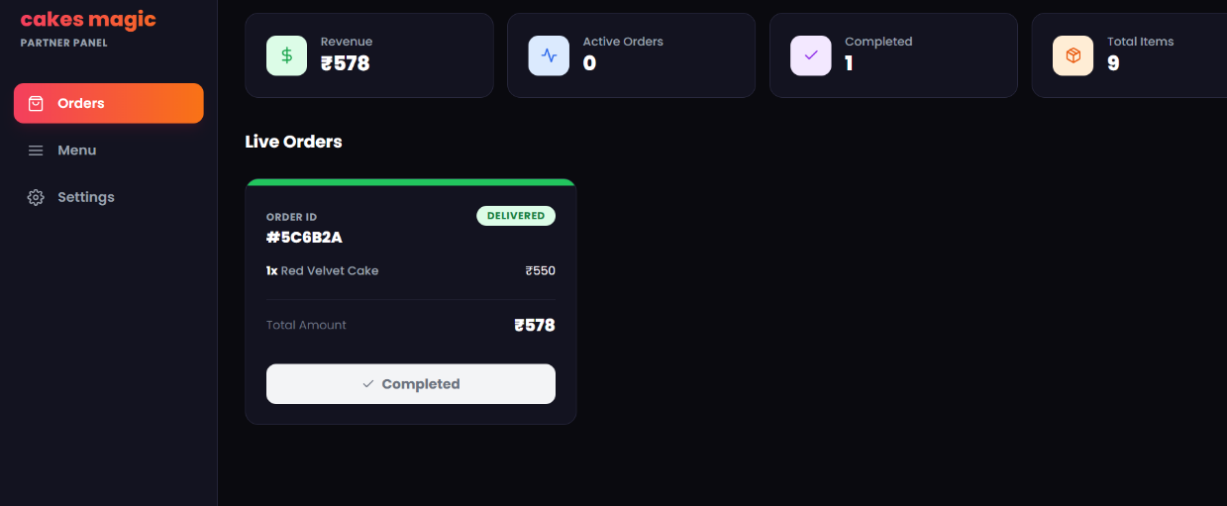
Figure-5: Restaurant Dashboard
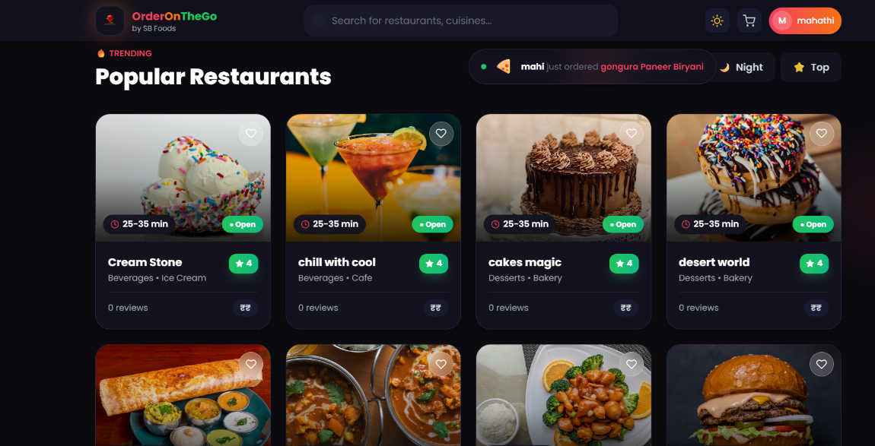
Figure-6: Popular Restaurants
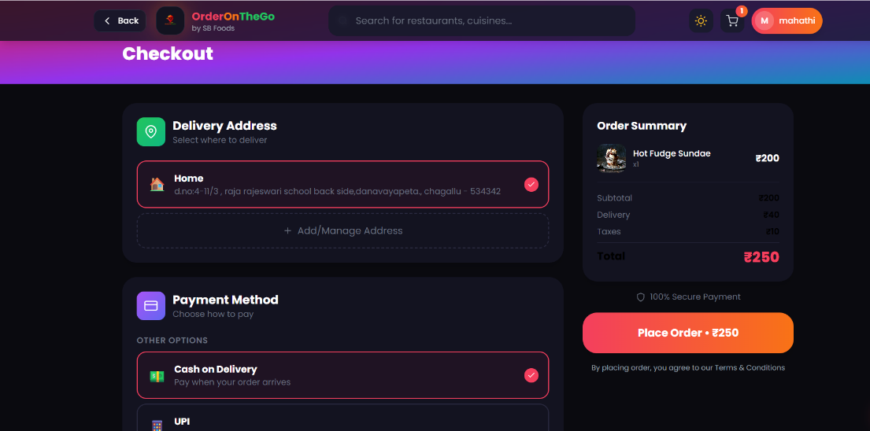
Figure-7: Checkout Page
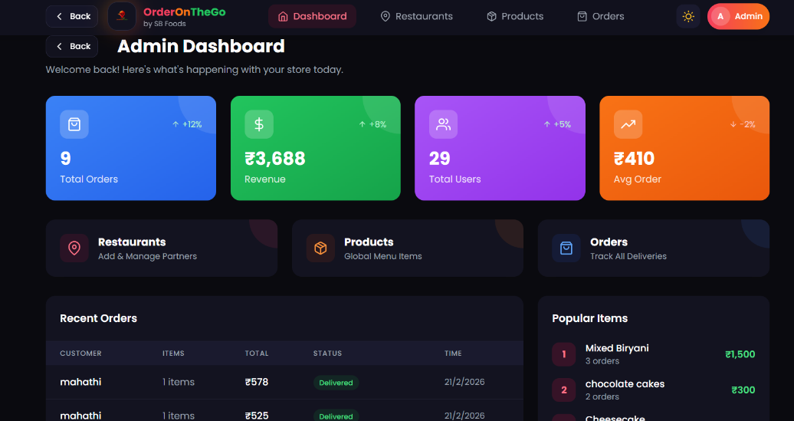
Figure-8: Admin Dashboard
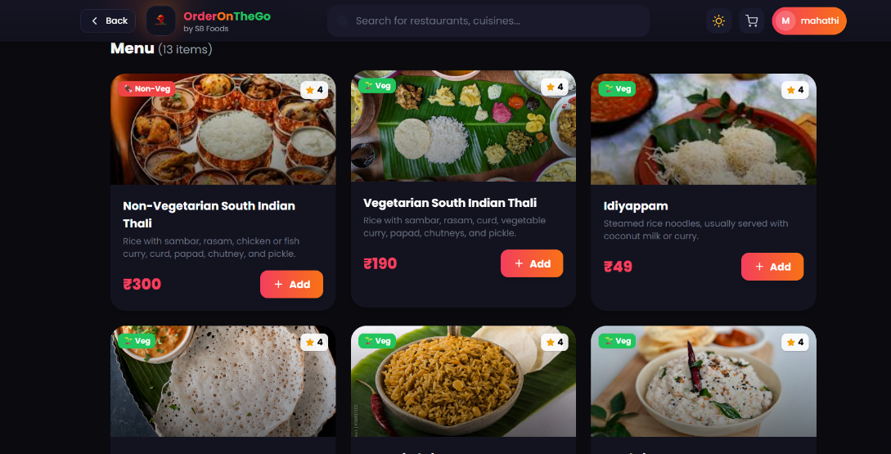
Figure-8: Restaurant Menu Listing Page

8. ADVANTAGES & DISADVANTAGES
Advantages
- Instant Food Ordering: Customers can browse restaurant menus and place orders quickly without manual coordination, reducing waiting time.
- Role-Based Access Control: Separate dashboards for Admin, Restaurant Owner, and Customer improve workflow management and ensure organized system operations.
- Cloud Database Integration: Using MongoDB Atlas provides scalability, secure data storage, and remote accessibility for users and restaurants.
- Secure Authentication: JWT-based login protects user accounts and ensures that only authorized users can access protected features such as order management and admin controls.
- Efficient Menu and Order Management: Restaurant owners can manage food items, update menus, and track incoming orders through a centralized dashboard.
- User-Friendly Interface: Developed with React.js and modern UI frameworks, providing a responsive and intuitive ordering experience.
Disadvantages
- Requires a stable internet connection to browse menus and place food orders.
- Food image loading performance may vary depending on network speed and file size.
- Currently supports only a web-based platform (no dedicated mobile application).
- Real-time order notifications and live tracking features may require further enhancement for better user experience.

9. CONCLUSION
The OrderOnTheGo Food Ordering Platform successfully addresses the limitations of traditional food ordering methods by providing a centralized and user-friendly digital solution. By leveraging modern web technologies such as React.js, Node.js, Express.js, and MongoDB Atlas, the system enables seamless interaction between customers, restaurant owners, and administrators.
The platform enhances convenience by allowing users to browse menus, place orders efficiently, and track order status through an integrated dashboard. Restaurant owners can manage food items and update order progress, while administrators maintain overall platform governance and security.

10. FUTURE SCOPE
- Mobile application development using React Native to enable food ordering on Android and iOS devices.
- Real-time push notifications using WebSockets or Firebase for instant order status updates.
- Payment gateway integration for secure online transactions using UPI, cards, or digital wallets.
- AI-based food recommendation system to suggest dishes and restaurants based on user preferences.
- Advanced analytics dashboard for restaurants and administrators to monitor orders and sales performance.

- APPENDIX
GitHub Repository:
https://github.com/poojitha-poshimshetti/OrderOnTheGo
Live Demo / Project Video:
https://drive.google.com/file/d/1afy-lmsBbqmpWzGKKzhpBWvjxShjguyc/view?usp=drivesdk

